**Assignment No 3 :**

**Joins :**

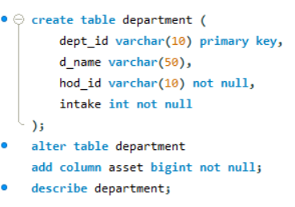

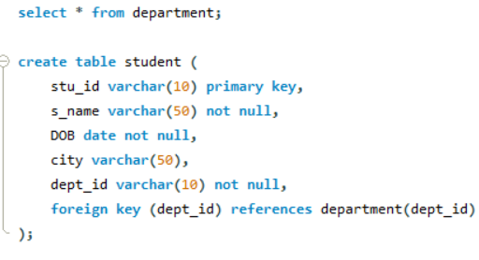

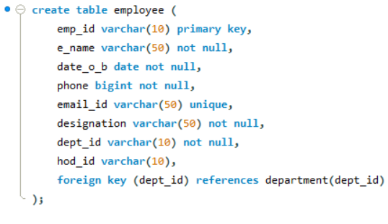

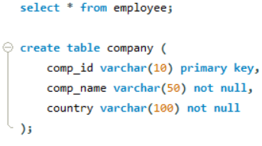

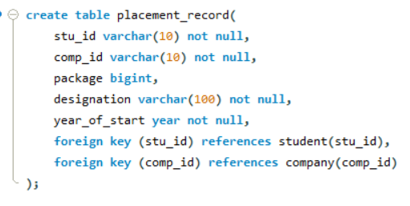

1. **List students details along with department name in alphabetical order of their name inner join using**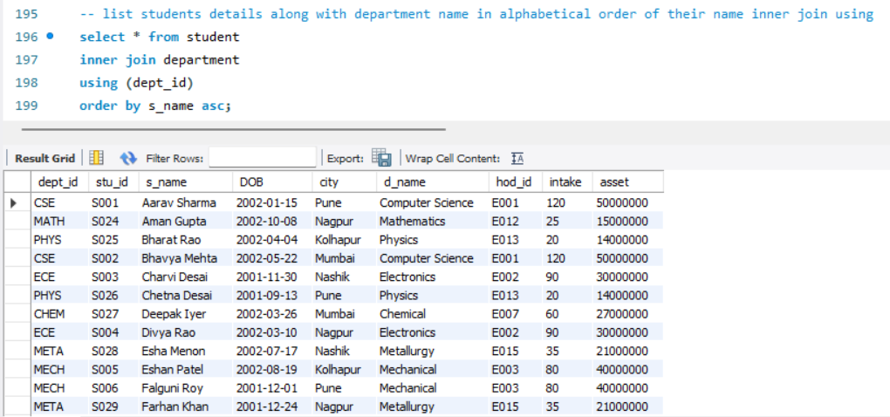
2. **List student details who belong to Pune city and whose department asset is more than 50 lakh inner join on**

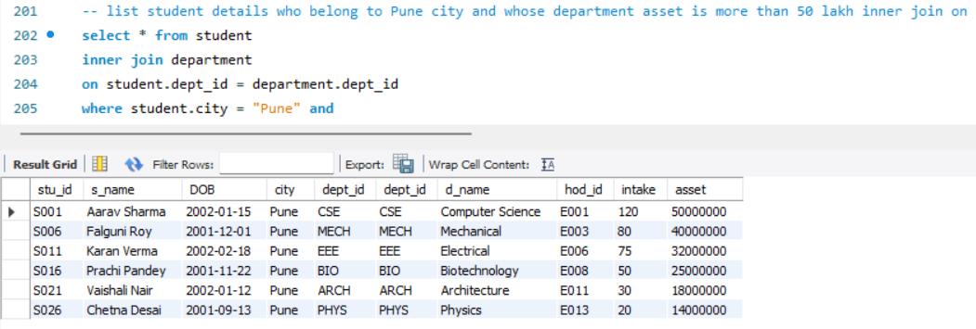

1. **Display employee name in capital letter whose name consist of *ji also print them in reverse order**

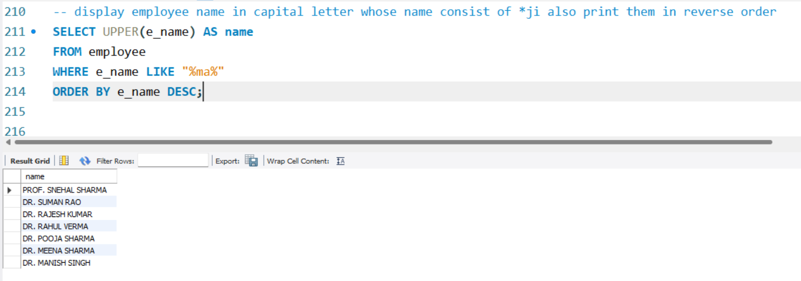

1. **List all students name, dob, if they are placed their packages and year of placement using left**

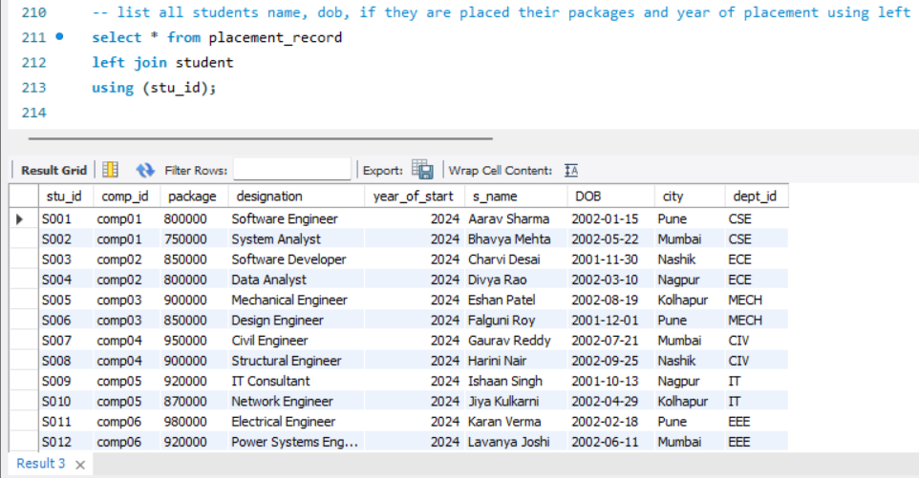

1. **Display student_id package placed along with company name country display company details using right join**

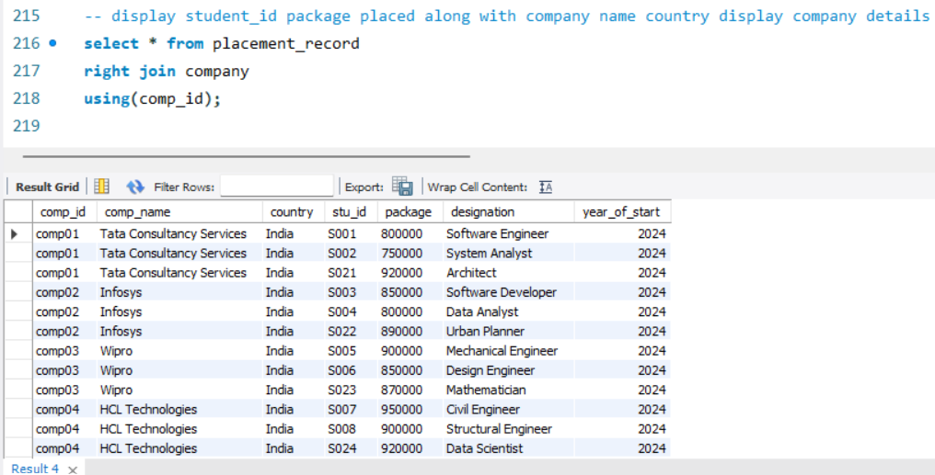

1. **Find student_name and with highest package**

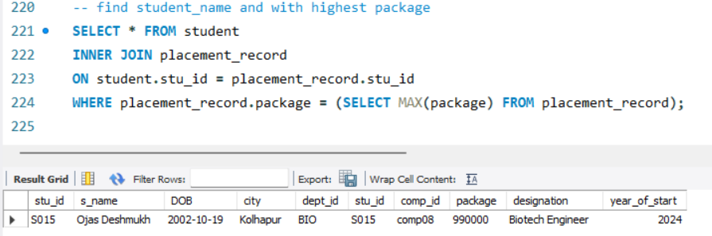

1. **List hod details along with department name whose intake is more than 100 using natural join**

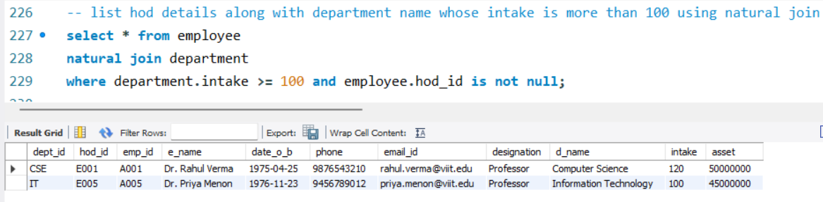

1. **List company details who have recruited students in year 2024**

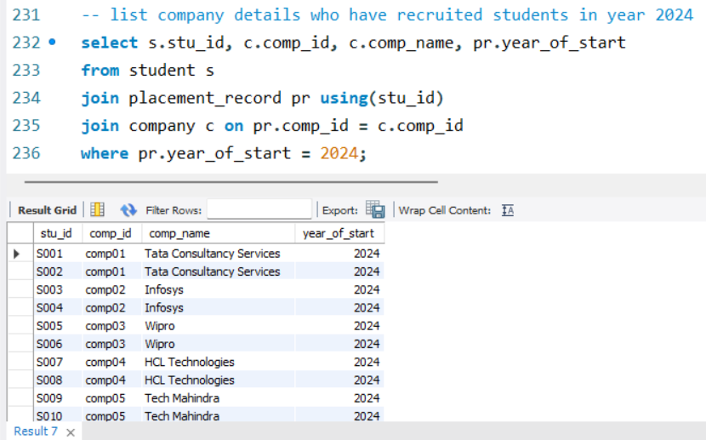

1. **List students from MECH department who are placed with a package of more than 6 lakh**

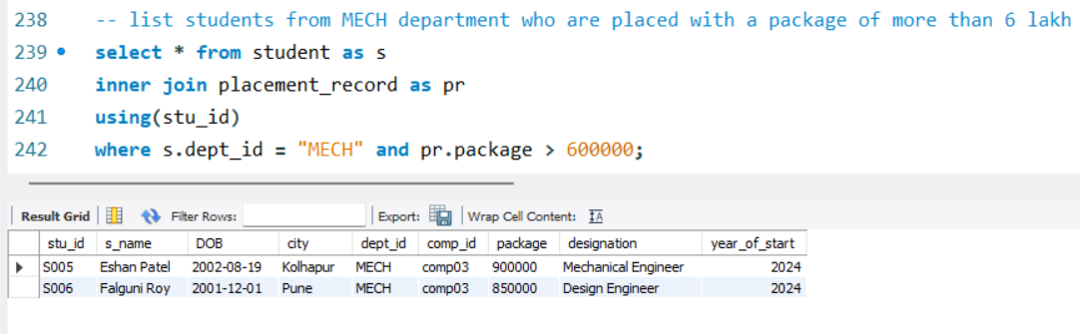

1. **List student_name who are placed in Infosys**

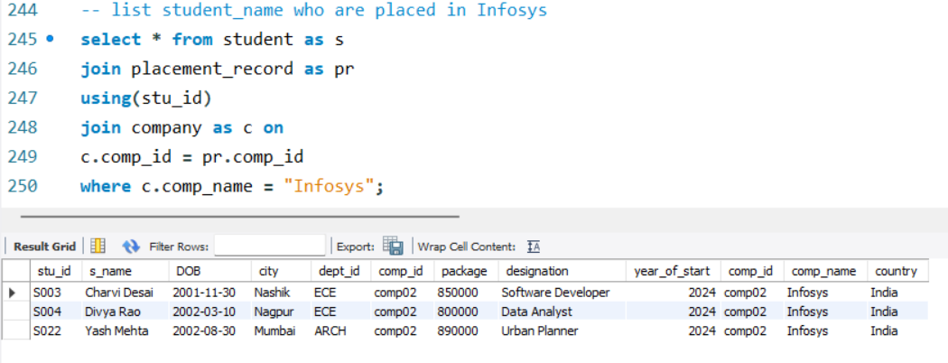

**Views:**

1. **Create table place with column level primary key with auto-increment**
2. **Create customer table with table level primary key.**
3. **Create booking table with table level foreign key constraint later add primary key and foreign key constraints**
4. **Add some records**

